Stay Safe from Fraud & Scams
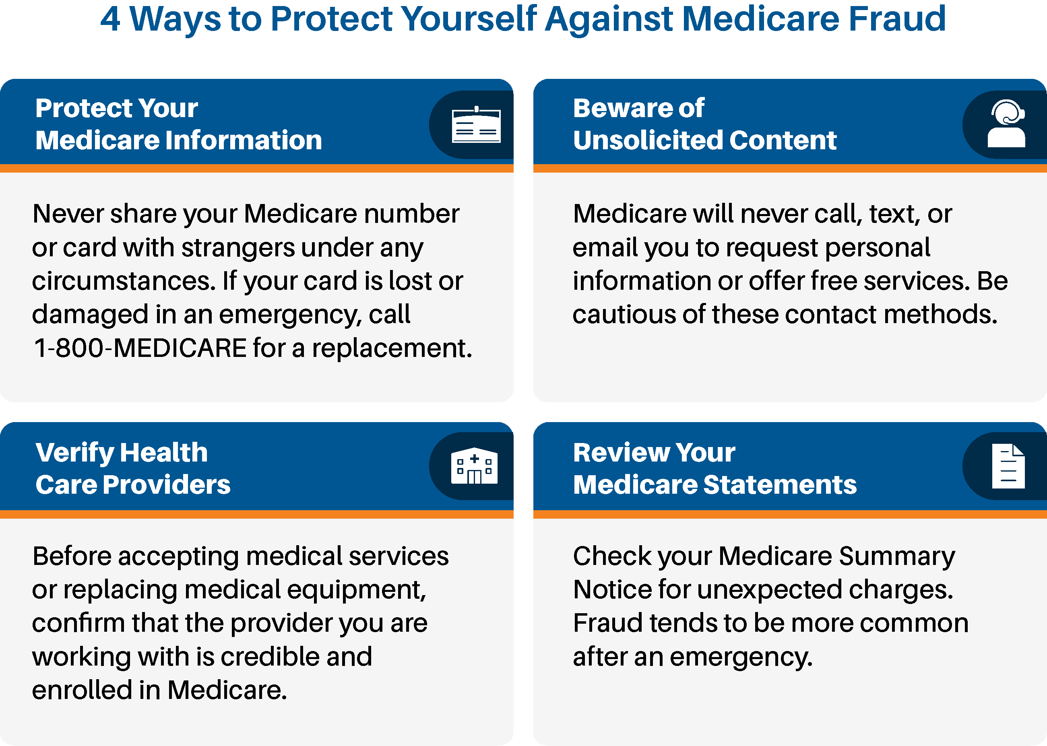
As [emergency] affects our community, scammers may try to take advantage of Medicare beneficiaries like you. Stay informed and protect yourself with these important tips.
Report Medicare Fraud
If you suspect fraud or have concerns over your personal information, contact [Local SMP name] at [Local SMP email/number] or visit [Local SMP Website].

