Digital Content

Sample Social Media Posts
Use these sample social media posts and graphics to share timely updates with the public during emergencies. You can post each graphic separately or combine them into a carousel post that allows you to swipe through all of them.
Post 1 | Post 2
Sample copy:  Emergencies can be stressful, but protecting your Medicare benefits doesn’t have to be. Follow these four essential tips to safeguard your information and prevent fraud during emergencies. | Sample copy:  Never share your Medicare number with strangers, even in an emergency. If your card is lost or damaged, call 1-800-MEDICARE for a replacement.
Graphic:  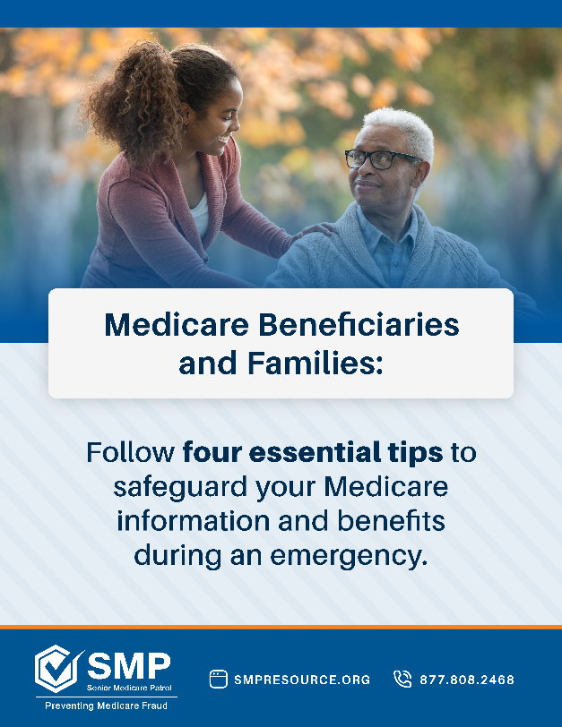 | Graphic:  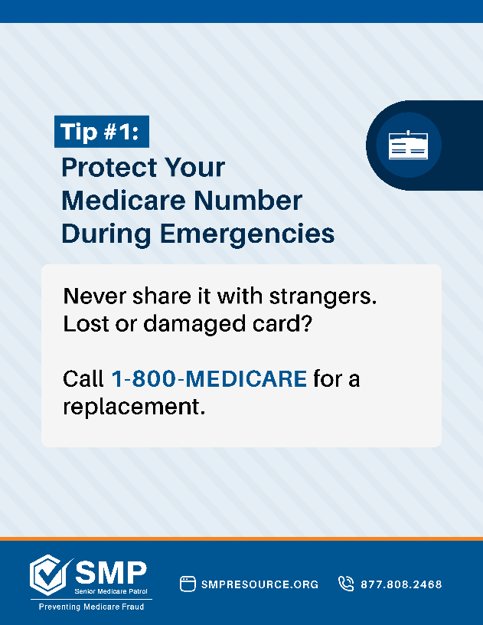

Post 3 | Post 4
Sample copy:  Scammers can take advantage of vulnerable individuals during an emergency. Stay vigilant and cautious when discussing your Medicare information with people. | Sample copy:  After a disaster, be cautious of people impersonating health care providers and suppliers. Protect yourself by verifying these individuals’ credentials before accepting aid.
Graphic:  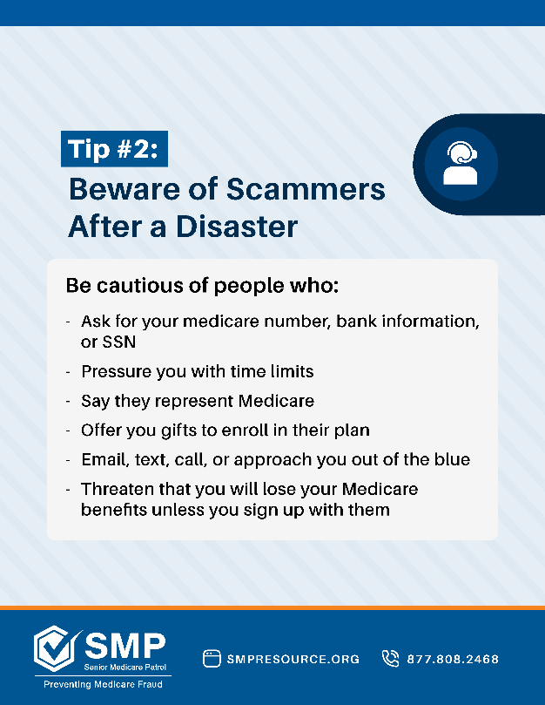 | Graphic:  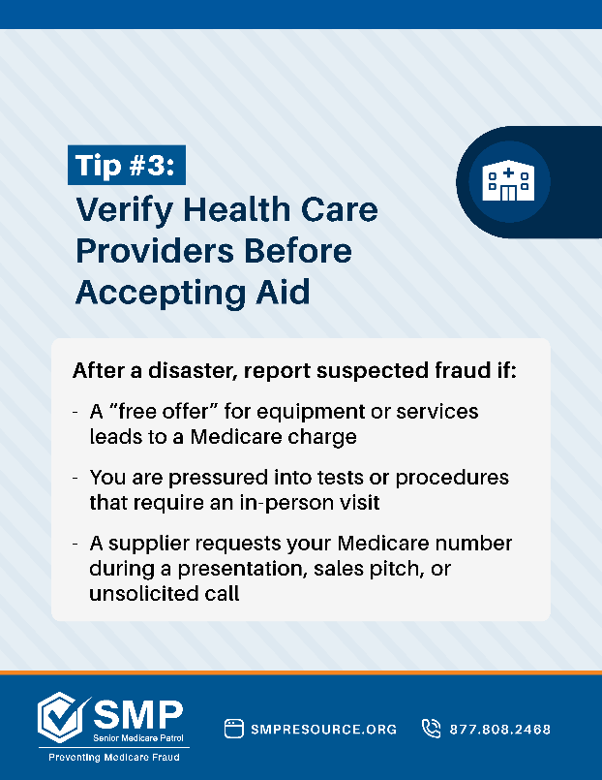

Post 5
Sample copy:
After an emergency, check your Medicare Summary Notice for any unusual or unknown charges. If you spot a mistake, contact us for help!
Graphic:
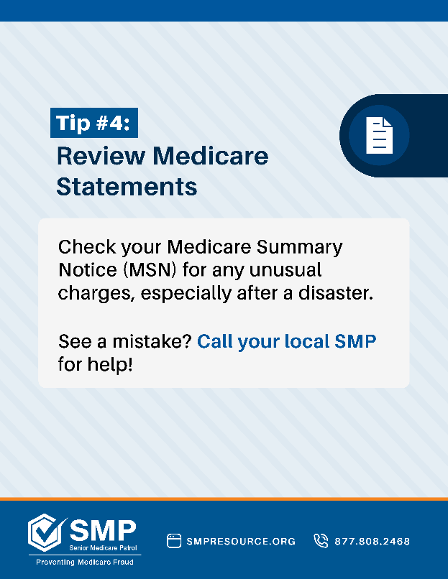

Sample Email Content
Use this sample email to provide beneficiaries and their families with important updates during emergencies. Customize the highlighted text with details specific to your local context. You can forward this email to key contacts in your network or include it in an e-newsletter.
Sample email message
Subject: Urgent Alert: Protect Your Medicare Benefits During [emergency]
Dear [Recipient’s name],
As [emergency] continues to impact our community, it’s important to stay alert against Medicare fraud and scams that often arise during crisis situations. Scammers take advantage of emergencies to target vulnerable individuals, and can pose as health care workers, Medicare representatives, or aid workers offering services or supplies.
At [Local SMP name], we are here to help you protect your personal information and Medicare benefits. Here are four key steps you can take to remain safe from scams and fraud:

- Protect your Medicare number: Never share your Medicare number with strangers. If your Medicare card is lost or damaged in an emergency, call 1-800-MEDICARE for a replacement.
- Beware of unsolicited contact: Medicare will never call or email you to ask for personal information. Be cautious of unexpected offers or requests.
- Verify health care providers: If someone offers medical services or equipment, confirm that they are legitimate before accepting their help.
- Review your Medicare statements: Check your Medicare Summary Notice for any unusual charges, especially after a disaster.
If you suspect Medicare fraud or have concerns over the safety of your personal information, please contact [Local SMP name] at [Local SMP email/number] or visit [Local SMP website].
We are here to help you! Stay safe, and remain vigilant,
[Local SMP Name]
[Local SMP email/number]
[Local SMP Website]

