Checklist for Counseling Remotely
Toolkit for Delivering Services Remotely

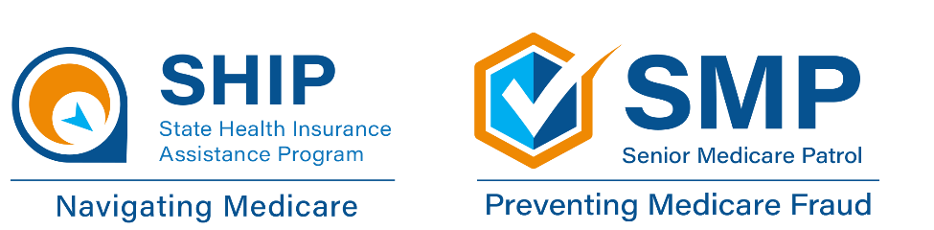

Contents
Overview 1
Scheduling 1
Preparing 2
Conducting the Session 3
Just prior to the call 3
Making the call 4
Phone calls 4
Video calls 4
Wrapping up the call 5

Overview
This document provides an outline that can be used as a checklist to prepare for a remote counseling session. When team members are counseling from remote workspaces, they need to be well-organized and have the session prepared in advance. The purpose of this checklist is to help with organizing a plan to conduct a successful remote session. This list is not all-inclusive and can be modified based on local program needs.

Scheduling
- Make sure you know what the client’s needs are, so the team member can prepare for the session.
- Ask the client if they prefer to have a phone call or a video call.
- Set up the appointment time and provide the client with the estimated length of their appointment and the team member’s name who will be meeting with them.
- To set up a phone call, let the client know that the phone number may come up on their phone as an unknown or restricted number. The team member may be using a messaging app or other technology. Team members may not be able to leave a call-back number. Ask the client to make sure to answer the call at your scheduled time, even though they may not know the number.
- To set up a video call, your organization may have procedures for certain video platforms. However, team members and clients may have a preference on what platforms they are comfortable using. From the options available, such as Zoom, Google Meet, WhatsApp, etc., ask the client what they prefer to use.
- Get the client’s email address and other needed information to set up the session and because your organization may require it in advance of a session.
- Ask the client if they feel comfortable and can receive documents by email. If so, request that the client check their email and spam folder before the session to access any documents sent in advance.
- If any protected health information (PHI) or personally identifiable information (PII) is needed from the client, send the client a secure email link and make sure all emails with PHI and PII are encrypted. (See “Delivering Personal Protected Information Remotely” in this toolkit.)
- If the client is not comfortable using email, mail them any information or forms needed prior to the session.
- Ask the client to have their list of prescribed medications and their Medicare number ready or if available, their Medicare.gov account login information, at the time of the session (if this information is not collected in advance with a secure method).
- Ask the client to make sure they have a quiet place, free from background noise or other distractions to have the session.
- Ask the client to cancel their session if they no longer need help or call to reschedule if they have something come up.

Preparing
- If the client has chosen a video call, set up the session on their preferred video call platform and email them the link to the session.
- Based on the client’s reason for the session, search for documents and links with information relevant to the client’s situation. You may have resources that you routinely share with clients, such as New to Medicare information, Extra Help, Medicare fraud education resources, etc. If the documents and links would be helpful for the client to review before the session, email or mail them to the client in advance.
- For clients who do not use email, consider waiting until after the session to mail the resources, since additional or more specific needs may come up during the session. Make notes of those resources.
- If the client has given permission and shared their Medicare.gov account login information, log into their account before the session to ensure you can access it. Familiarize yourself with their current plans and Extra Help eligibility status, as applicable. Update their prescribed medications, if you have the list.
- If you have received the client’s medications in advance, you can do a plan comparison on Medicare.gov before your session. Create a PDF of the plan comparison and/or plan details of the most cost-effective plans and save to your files to review with them at the session. You can also share the plan comparison and other relevant plan information with the client in advance.

Conducting the Session

Just prior to the call
- Check your surroundings for background noise and privacy for confidentiality. For a video call, be aware of what will show on camera. Close other desktop applications you have open for your own privacy and the security of other clients’ information.
- Open the document(s) you saved of the Medicare.gov plan comparison, Extra Help information, fraud education resources, and any other documents and links you may have shared with the client in advance or that you routinely use for the reason the client made the appointment.
- For a video call, review how you plan to screenshare the documents and links during the session and which resources you may want to send in chat, if applicable.
- For a phone call, be prepared to ask the client to have any documents and links you may have emailed or mailed them in advance.
- If the client has shared their Medicare account login information, have this information available to log in during the session.
- Check your email or phone for any client messages, especially if you think they are having difficulty with accessing the video call or having phone issues.

Making the call

Phone calls
- Be on time. The client may feel unsure about picking up a call from an unknown or restricted number at a time other than the scheduled session time.
- If the client does not answer, do not leave a call-back number since you are working from home or in another remote location. (Unless you use an agency cell phone and have an established procedure for taking client calls.) You can leave a message stating your name, your agency/organization, that you’re calling for a scheduled session, and state that you will call back in 5 minutes.
- If the client doesn’t answer the phone the second time, you can leave a final message stating that they will need to contact the agency again to set up another session. How many times you try calling or messages you leave will depend on your agency’s protocol. If able, ask someone from your organization who has an agency phone number and caller ID to call the client back. If the client answers, they can ask them to pick up your call from the unfamiliar number.

Video Calls
- Log in several minutes before the session time to help with any technical issues.
- Adjust your camera position, background, and video settings for light level.
- Test your speakers and microphone in audio settings and adjust to remove background noise.
- Watch for the client to join the call and if needed, give permission to allow them to join, depending on your video call platform.
- Review with the client some of the features of the video call platform, including muting and chatting.
- Allow for a balance of screensharing of information and face-to-face discussion during the session. Include time for questions.
- More tips and etiquette on video calls can be found in “Technologies for Counseling Remotely” in this toolkit.

Wrapping up the call
- Discuss the next steps. A list will help the client to be organized and know what actions they may need to take.
- Ask the client whether they prefer you to email or mail them any follow-up information.
- When you have ended the phone call or video call, plan to send any documents and links you offered to send, as they may already be open on your computer or on your desk. It is important to be timely with any follow-up information or items.
- Make notes for documentation and data entry. If you cannot immediately send follow-up information to the client, note any documents or links that you need to send the client and schedule time for follow-up.

This resource was supported by the Administration for Community Living (ACL), U.S. Department of Health and Human Services (HHS) as part of a financial assistance award totaling $2,534,081 with 100 percent funding by ACL/HHS. The contents are those of the author(s) and do not necessarily represent the official views of, nor an endorsement, by ACL/HHS, or the U.S. Government.

