Administration for Community Living Office of Healthcare Information and Counseling

Managing Through COVID-19 Work grouP - September 2020

In-Person Counseling During the COVID-19 Pandemic

Preparing for Remote Medicare Open Enrollment Toolkit

Contents

Introduction 1

How to Protect Yourself & Others 2

How Do You Approach Someone Who Won’t Wear a Mask? 6

Outdoor Curbside Appointments - Office Setup 6

Indoor In-Person Appointment Office Setup 8

Using Multiple Monitors to Minimize Sharing of Equipment and Paperwork 11

Helping Clients Prepare For Appointments 13

Concluding the Counseling Session 15

# Introduction

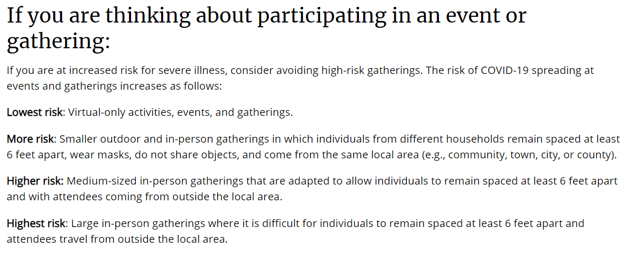Depending on local guidelines, some agencies may be able provide some limited in-person counseling during the pandemic. Keep in mind that the safest option for the counselor and client is to provide counseling by phone or web; however, if in-person counseling is necessary, the agency should take precautions to keep all participants as safe as possible. Here are recommendations from the Centers for Disease Control (CDC)[1]:

# How to Protect Yourself & Others

Older adults and people who have severe underlying medical conditions, such as heart disease, lung disease, or diabetes are at a higher risk for developing serious complications from COVID-19.

## Know how it spreads

There is currently no vaccine to prevent coronavirus disease 2019 (COVID-19). The best way to prevent illness is to avoid exposure to the virus. The virus is thought to spread mainly from person-to-person:

* Between people who are in close contact with one another (within about 6 feet).
* Through respiratory droplets produced when an infected person coughs, sneezes or talks.
* These droplets can land in the mouths or noses of people who are nearby or possibly be inhaled into the lungs.
* Some recent studies have suggested that COVID-19 may be spread by people who are not showing symptoms.[2]

## Prevent the spread

**Wash your hands often.**

* Wash your hands often with soap and water for at least 20 seconds, especially after you have been in a public place or after blowing your nose, coughing, or sneezing.
* It is especially important to wash your hands:
  + Before eating or preparing food
  + Before touching your face
  + After using the restroom
  + After leaving a public place
  + After blowing your nose, coughing, or sneezing
  + After handling your mask
  + After caring for someone who is sick
  + After touching animals or pets
* If soap and water are not readily available, use a hand sanitizer that contains at least 60% alcohol. Cover all surfaces of your hands and rub them together until they feel dry.
* Avoid touching your eyes, nose, and mouth with unwashed hands.[3]

**Avoid close contact.**

* Inside your home: Avoid close contact with people who are sick.
  + If possible, maintain 6 feet between the person who is sick and other household members.
* Outside your home: Maintain 6 feet of distance between yourself and people who don’t live in your household.
  + Remember that some people without symptoms may be able to spread the virus.
  + Stay at least 6 feet (about 2 arms’ length) from other people.
  + Limit the time you are around people. The longer you spend around other people, the higher your risk of becoming sick.
  + Maintaining distance from others is especially important for people who are at a higher risk of getting very sick.
* Clients often exchange handshakes at meetings. Display signs that discourage these actions during in-person events.[4]

**Cover your mouth and nose with a mask when around others.**

* You can spread COVID-19 to others even if you do not feel sick.
* Masks are meant to protect other people in case you are infected.
* Everyone should wear a mask in public settings and when around people who don’t live in their household, especially when other social distancing measures are difficult to maintain.
  + Masks should not be placed on young children under age 2, anyone who has trouble breathing, or anyone who is unconscious, incapacitated or otherwise unable to remove the mask without assistance.
* Continue to maintain about 6 feet of distance between yourself and others. Masks are not a substitute for social distancing.
* Provide all staff and clients with information on proper use and removal of masks.
* Advise staff that masks should not be placed on:
  + Anyone who has trouble breathing
  + Anyone who is unconscious, incapacitated, or otherwise unable to remove the mask without assistance
* Before holding in-person events, encourage clients to bring and use masks at the event.[5]

**Cover coughs and sneezes.**

* Always cover your mouth and nose with a tissue or the inside of your elbow when you cough or sneeze.
* Throw used tissues in the trash.
* Immediately wash your hands with soap and water for at least 20 seconds. If soap and water are not readily available, clean your hands with a hand sanitizer that contains at least 60% alcohol.[6]

**Clean and disinfect.**

* Clean and disinfect frequently touched surfaces within an in-person meeting location at least daily or between uses as much as possible. For example, door handles, sink handles, drinking fountains, grab bars, hand railings, tables, and keyboards should all be disinfected.
* Consider closing areas such as drinking fountains that cannot be adequately cleaned and disinfected during an event.
* If surfaces are dirty, clean them. Use detergent or soap and water prior to disinfection. Next, use a household disinfectant. Most common EPA-registered household disinfectants will work.
* Develop a schedule for increased routine cleaning and disinfection.
* Plan for and enact these cleaning routines when renting event space and ensure that other groups who may use your facilities follow these routines.
* Staff should ensure that there is adequate ventilation when using these products to prevent attendees or themselves from inhaling toxic vapors.
* Use disposable gloves when removing garbage bags or handling and disposing of trash.
  + After using disposable gloves, discard them in a lined trash can.
  + Do not disinfect or reuse the gloves.
  + Wash hands after removing gloves.[7]

**Monitor your health daily.**

* Be alert for symptoms. Watch for fever, cough, shortness of breath, or other symptoms of COVID-19.
  + This is especially important if you are running essential errands, going into the office or workplace, or in a setting where it may be difficult to keep a physical distance of 6 feet.
* Take your temperature if symptoms develop.
  + Don’t take your temperature within 30 minutes of exercising or after taking medications that could lower your temperature, such as acetaminophen.
* Follow CDC guidance if symptoms develop.

**Stay home when appropriate.**

* Educate staff and clients about when they should stay home.
  + Advise staff and clients to stay home if they have tested positive for COVID-19 or are showing COVID-19 symptoms.
  + Advise staff and clients to stay home and monitor their health if they have had a close contact with a person who has symptoms of COVID-19 within the past 14 days.[8]

**Provide adequate supplies.**

* Ensure that staff, volunteers, and clients have access to adequate supplies to support healthy hygiene behaviors. These supplies include soap, water, hand sanitizer containing at least 60 percent alcohol, paper towels, tissues, disinfectant wipes, masks (as feasible), and no-touch trash cans.
* Post signs[9] in highly visible locations (e.g., at entrances, in restrooms) that promote everyday protective measures and describe how to stop the spread of germs by properly washing hands and properly wearing a mask.
* Consider developing signs and messages in alternative formats (e.g., large print, braille, American Sign Language) for people who have limited vision or are blind or people who are deaf or hard of hearing.[10]

# How Do You Approach Someone Who Won’t Wear a Mask?

During the COVID-19 pandemic, mask orders vary from state to state and even from location to location. This has created confusion and even conflict among members of the public. In the context of in-person counseling, organizations will have established rules for the behavior of staff, volunteers, and attendees, and those rules will likely involve mask use. It will be important that all participants follow the rules. Here are some diplomatic approaches for talking with individuals not wearing the required masks:

* “I believe we are supposed to be wearing a mask.”
* “Excuse me, but we are required to wear masks at all appointments. Could you please put on your mask before we continue? Otherwise, we can set up an appointment for phone counseling.”
* “We’re wearing masks here today to protect ourselves and each other.”
* “Excuse me, but I need to step away.”
  + Use this method to remove yourself from a potentially unsafe situation if the person you are near will not respond to gentle reminders for mask wearing.
  + Contact the person in charge of the event. They will need to address the situation.

## Set an example.

Staff and volunteers will need to set an example by following the rules and wearing masks. Mask wearing also shows respect and consideration for others. You can see a smile through a facemask - your eyes will smile!

# Outdoor Curbside Appointments - Office Setup

## #CounselingWithCareCurbside

For those programs who will be offering in person appointments, it is important to create a counseling space that protects both the counselor and clients during the session. The following guidelines are suggested to use when hold in-person appointments outdoors, or “curbside.” This is a safer route for those warmer states that can consistently hold outdoor counseling.

The Florida SHINE program launched a new ***#CounselingWithCareCurbside*** project to serve beneficiaries in need of in person assistance. This model allows them to continue to provide counseling services to clients, their families, and their caregivers. It also helps volunteers -- who may also be members of the identified vulnerable populations -- feel more at ease returning to their counseling activities.

Possible partners for curbside counseling could include Area Agencies on Aging (AAAs), Aging and Disability Resource Centers, libraries, and senior centers. Safety measures should be consistent with those used for in-person counseling. Confidentiality measures should also be consistent, with participants protected from having their counseling sessions overheard by passersby. The weather should be taken into consideration when scheduling curbside counseling. Avoid times of day that will be too hot, too cold, or too dark.

## Personal protective equipment (PPE) and other measures to be safe and successful

* Tents outfitted with the program logo to allow for a branded, shaded, safe space for volunteers and support staff to provide drive-up services
* Folding chairs to be assigned to each volunteer
* Provide face masks
* Individual hand sanitizer bottles to be used between each client interaction
* Disposable pens in a plastic sleeve that will be used for each client and given to that client at the conclusion of the session
* A clear shower curtain to hang from the front of each tent to ensure additional protection
* Access to electricity for laptops

## Marketing tools

* Promote counseling events over the radio and direct clients to the program’s local website for specific curbside counseling locations and dates.

## Getting your clients ready for drive-thru counseling

* Clients should be pre-screened for their individual counseling needs, which will allow staff and volunteers to be prepared for each drive thru interaction and minimize the exchange of sensitive information.
* For more complex cases, an initial screening will be completed at the curbside counseling session, and then a follow-up counseling session will occur over-the-phone.

# Indoor In-Person Appointment Office Setup

For those programs who will be offering in person appointments, it is important to create a counseling space that protects both the counselor and clients during the session. The following guidelines are suggested to use when holding in-person appointments indoors.

## Appointment Space Parameters and Setup

* Space utilized for appointments should be near the entrance of the office or building to minimize exposure to others working in the office.
* Each counseling space should be in a separate room.
* Counseling stations should be set up with at least six feet between counselor and beneficiary.
* Counseling space should include one chair that will only be used by counselor, one six-foot table, and two chairs for clients that can be easily cleaned.
  + Ideally, all chairs should be made from plastic or another material that can easily be cleaned. Fabric chairs should be avoided if possible.
* Each station should have a Plexiglas divider separating the counselor from beneficiaries.
  + The Plexiglas divider should be as large as possible. The barrier in the photos below measures 4 feet by 4 feet.
* The counselor’s seat should be located close to the door. This will allow the counselor to leave the room, if needed, without walking by the beneficiary

## Example photos

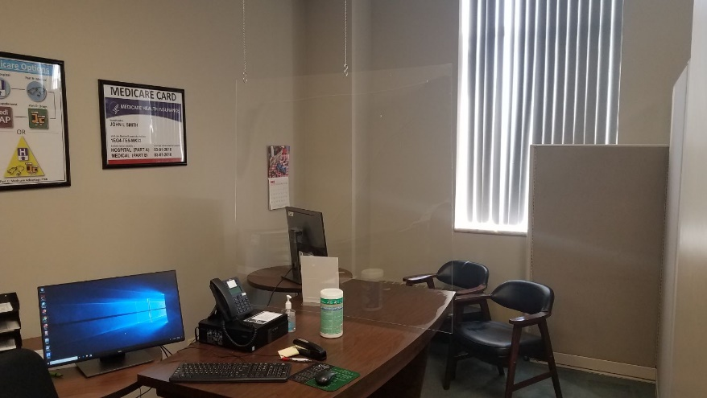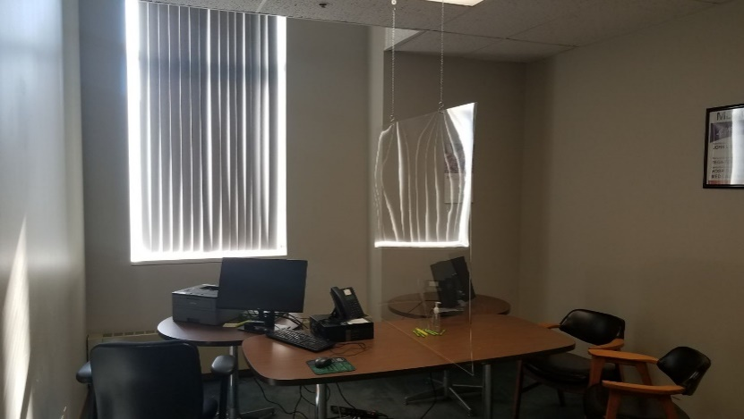

## Equipment Requirements

The following items should be on the counselor’s side of the station:

* Main computer
* Printer
* Phone
* Hand sanitizer
* Stapler

The following items should be on the client’s side of the station:

* A second monitor mirrored to the main computer
* Mirroring the monitors allows the clients to see the same thing as counselor.
* The monitor should be attached to the main computer with an HDMI cord of at least 6 feet.
* If the space in the room allows, a projector or large TV screen may be used as the second monitor
* Hand sanitizer

## Material distribution

* A material packet should be assembled prior to the counseling session which will include any brochures, forms, or other documents the client may need.
* One packet will be placed on the client side of the table. The client must take this packet with them when they leave.
* Individual pens and highlighters will be placed on the client side. The client must take these items with them after the session.
  + If possible, pens should be prepackaged. If this is not possible, pens should be sanitized prior to giving them to the client.

## Post-appointment clean-up

* Counseling stations should be sanitized between each client session.
  + All hard surfaces that the client may have come in contact with should be wiped down with sanitizer
  + This includes chairs, table/desk, computer monitor, Plexiglas, doorknobs, light switches, etc.
* If client uses the restroom while in the office, restrooms should be sanitized as well
* The counselor should wash their hands between each counseling session.

## Appointment scheduling

* It is important to leave enough time between appointments to allow for the necessary sanitizing procedures.
* A break time of 15 minutes should allow for office cleaning before the next session.

## Counselor safety reminders

* Wear personal protective equipment, such as a mask and face shield.
* Do NOT shake hands or give hugs.
* Collect necessary information, such as drug lists, via email prior to the appointment to minimize contact through passing documents back and forth.

## When clients arrive

**If client has a cell phone**

* When the client enters the parking lot, they should call to notify the front desk that they have arrived for their appointment. The receptionist should provide instructions about the counseling site’s safety precautions, and, in most cases, inform the client that the counselor is with another beneficiary.
* The receptionist will ask the client what phone number they would like to be called back on when their counselor is available, at which time they may enter the building.

**If client does not have a cell phone**

* The client should check in for their appointment at the front desk.
* The receptionist will confirm the client’s appointment time, provide instructions about the counseling site’s safety precautions, and, in most cases, inform the client that the counselor is with another beneficiary.
* The receptionist will inform the client that they should return to their car and wait for a gesture, sign, visual or other notification that it is time for their appointment.
  + The method of notification should be determined in advance of the event and should take into consideration the needs of people with vision or hearing impairments.
* Once notified, the client may enter the building, following the other safety protocols that are outlined for the event.

# Using Multiple Monitors to Minimize Sharing of Equipment and Paperwork

If you are planning to conduct in-person counseling, there are ways to let technology do some of your work for you. This will reduce exposure due to sharing equipment and transferring items between you and your client. Below are some tips and tricks to help you set up your workstation to successfully accomplish this task.

## Choices

Counselors may already have one or two displays or monitors. Having two monitors is useful when comparing or moving information between different applications or windows. A third monitor can be used to show the information on the screen to the beneficiary facing you.

In an ***extended display***, each monitor shows different windows or programs. You can mouse from one display to the other.

In a ***duplicate display***, one monitor mirrors the other. Duplicate displays allow for the physical distancing needed during the COVID-19 pandemic. The counselor sits at one end of a table and the beneficiary sits at the other end, facing the counselor and seeing a duplicate display.

## Connections

Depending on the age and model of the equipment, different connections are possible. Here we describe the most common scenarios. The computer and its graphics display adapter may offer one or more of the following display ports:

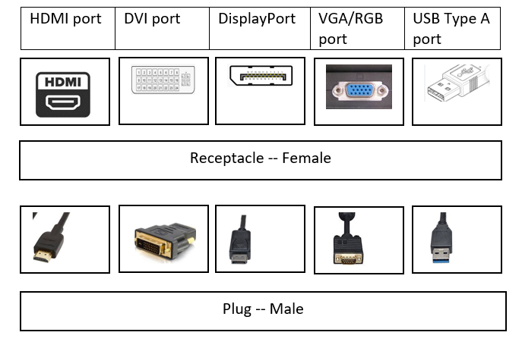The monitor will also offer one or more of these same ports. Check to make sure that this is the case.

Usually a computer graphics display adapter accommodates two monitors – commonly DVI and VGA. For a third display that mirrors one of the first two, a signal splitter accomplishes the task. You may need:

* HDMI splitter
* DVI splitter
* DisplayPort splitter
* VGA splitter
* USB A splitter

## Plan ahead

Before ordering connections and cables, plan ahead: note the type of connection you need and the distance between the counselor and the beneficiary. Different connections and combinations may not work as expected. Purchase cables and connection devices that you can return.

## Configurations

In Windows 10, configure your display setup as follows:

* Click ***Start*** and type ***Displays***. Alternately, press the Windows key and the letter P at the same time.
* If you are working with two displays:
  + Click ***Start***, click on the geared wheel for ***Settings***, and click on ***System***.
  + Click ***Display***.
  + Scroll down and click ***Multiple Displays****.*
  + You can choose to extend or duplicate these displays.
  + To extend these displays in order to show different windows and programs on each display, click ***Extend these displays***.
  + To duplicate these displays in order to show the same image on both displays, click ***Duplicate these displays***.
  + If you are working with three monitors and the computer’s graphics adapter card accommodates only two, use a signal splitter for the duplicate displays seen by the counselor and the beneficiary.

## 

## Be Safe & Protect Your Equipment

Before making your connections, power down and unplug the computer and the monitors. If necessary, create a drawing of how the computer and monitors will connect. You can also use this drawing:

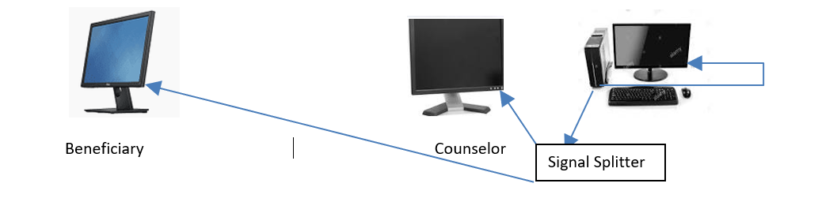

# Helping Clients Prepare For Appointments

To minimize exchange of paperwork and to reduce the time for each counseling session, we recommend that counselors send some pre-counseling homework to their clients. The more prepared the clients are, the easier it will be to assist them. There is sample messaging, including scripts and text for pre-appointment letters as part of the Preparing for Remote Open Enrollment Toolkit. Here are some ideas for other information you could provide in advance as part of your letters or emails.

## Medicare 101 Recording

Record a Medicare 101 presentation and give clients an opportunity to view this before meeting with a counselor. This will help the clients to determine what questions they might have prior to their session. An example of this can be found in the video below: <https://www.youtube.com/watch?v=eig7wX62yOg&feature=youtu.be>

## Be signed up for a MyMedicare.gov account

The Centers for Medicare & Medicaid Services (CMS) provide MyMedicare.gov accounts and helpful resources for using them. To create a MyMedicare.gov account, [click here](https://www.mymedicare.gov/). CMS Product No. 12064 ([click here](https://irp-cdn.multiscreensite.com/a8a8e955/files/uploaded/Create%20Your%20Medicare%20Personal%20Account.pdf)) provides additional instructions and a space for beneficiaries to write down their information for future access.

Several State Health Insurance Assistance Programs (SHIPs) have created video tutorials to help people through the process of account creation. Here’s one from New Jersey on YouTube:

* <https://www.youtube.com/watch?v=i6imlBKikSg>

Clients will need to remember their Medicare number. You can provide them with resources to help them remember their information. For example, you can send a card like the one provided in Florida:

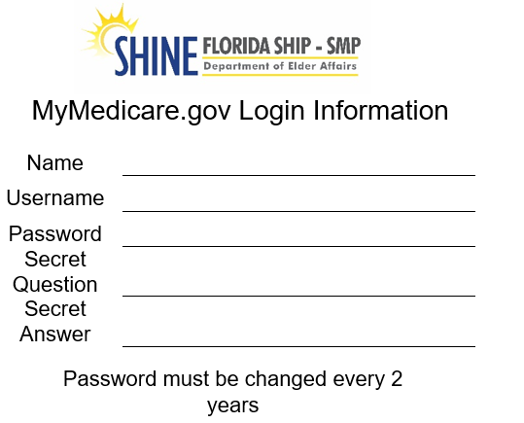**Front of card: Back of card:**

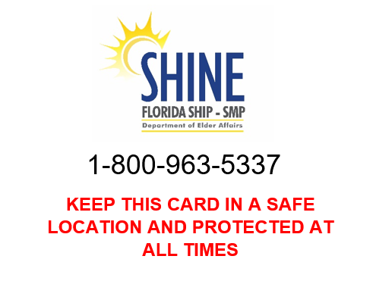

## Pre-enrollment Form

A pre-enrollment form, also known as a counseling worksheet, is a great tool to help clients get organized and identifies all the information counselors need to assist them. It also reduces the likelihood that clients will bring a bag of medications into the appointment. Counselors should not be handling these items. Most Medicare counseling programs have such forms, but there is a sample as part of the Preparing for Remote Medicare Open Enrollment Toolkit. It also includes space for them to enter their MyMedicare.gov account information.

# Concluding the Counseling Session

When the counseling session is finished, it is important to make sure the client knows that all documents will be returned to them and not kept on file. Another best practice is to show the client how to change their MyMedicare.gov account password. Below are the steps necessary to do this.

## Resetting a MyMedicare.gov Account Password

If a person does not remember their MyMedicare login information, it can be retrieved and reset.

* 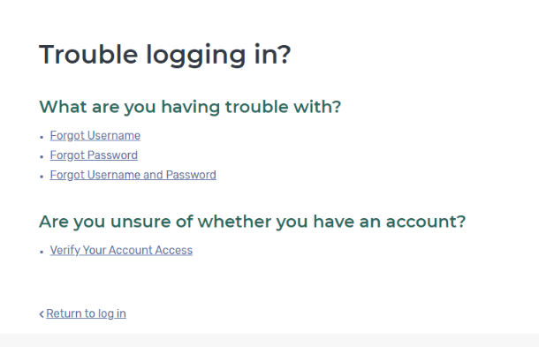When you are on the login page, click “***Trouble logging in?***”
* On the next screen, select the option you need to retrieve. In this example, we will reset the password.
* Next, enter the information requested on the screen.
* When the account was created, a secret question was created. Enter the answer to the secret question. The system allows for three incorrect answers before the account is locked.
* You can now select a new password and enter it below. On the right-hand side of the screen, the password guidelines are listed.

You can also provide this CMS document, in print or as a link, about setting up a temporary password for individuals without an email address: <https://www.medicare.gov/sites/default/files/2020-01/Medicare-account-password-reset-without-email-508.pdf>

1. *:* <https://www.cdc.gov/coronavirus/2019-ncov/need-extra-precautions/older-adults.html>
2. <https://www.cdc.gov/coronavirus/2019-ncov/prevent-getting-sick/prevention.html>
3. <https://www.cdc.gov/coronavirus/2019-ncov/prevent-getting-sick/prevention.html>
4. <https://www.cdc.gov/coronavirus/2019-ncov/prevent-getting-sick/prevention.html>
5. <https://www.cdc.gov/coronavirus/2019-ncov/prevent-getting-sick/prevention.html>
6. <https://www.cdc.gov/coronavirus/2019-ncov/prevent-getting-sick/prevention.html>
7. <https://www.cdc.gov/coronavirus/2019-ncov/prevent-getting-sick/prevention.html>
8. <https://www.cdc.gov/coronavirus/2019-ncov/prevent-getting-sick/prevention.html>
9. Signs are available at <https://www.cdc.gov/coronavirus/2019-ncov/communication/print-resources.html?Sort=Date%3A%3Adesc>
10. <https://www.cdc.gov/coronavirus/2019-ncov/prevent-getting-sick/prevention.html>