Administration for Community Living Office of Healthcare Information and Counseling
Managing Through COVID-19 Work grouP - September 2020

One-on-One Counseling Over the Phone
Preparing for Remote Medicare Open Enrollment Toolkit

Contents
Introduction 1
Setting up a Google Voice Account 1
How to Make a Three-Way Call Using a Cell Phone 2
Scanning Documents 3

Introduction
The purpose of this document is to give program staff and volunteers best-practices for successful one-on-one over-the-phone counseling. It has been broken down by programs for iPhone, Android, and tablets. This is not an all-inclusive list, but it provides the most reasonable, free, and reliable choices available. You will find options for one-on-one calls, conference calls, and scanning.

Setting up a Google Voice Account

Android or iPhone
- Download the Google Voice app on your smartphone. It is available for Android and iOS.
- Open the app and sign into your Google account. If you do not have one, you will need to set one up.
- You will see a message that says “Welcome to Google Voice, a free phone number to take control of your communication. By continuing, you accept the Terms of Service and Privacy Policy.” Links are available to both documents.
  - Click Continue.
- Choose a Google Voice number. You can search for available numbers by city or area code.
  - Click Search.
  - Pick your city of residence.
  - A list of available numbers should appear. Select one and click Accept Number.
- You can link this device to Google Voice to make and receive Google Voice calls with this device. If you don’t want to make Google Voice calls with this device, you can verify your account with a different phone number. If you choose this option, inbound calls to your Google Voice number will be forwarded to a different number.
  - Follow the link provided and enter your personal cell phone number (or a different number).
  - Google will send you a text message containing a 6-digit code. You can also verify by receiving a call.
    - Click Send Code.
    - Enter your 6-digit code received via text message.
  - You will see a message that says, “Do you want to use your Google Voice number when calling from this device’s phone app?”
    - Options given include:
      - Yes (all calls)
      - Yes (International calls only)
      - Select number before each call
      - No
    - We recommend choosing “Select number before each call.”
    - Click Next.
    - Your Google Voice number is now linked! Your device will ring when someone calls your Google Voice number.
    - Click Finish.
- When you make an outgoing call, you will get a message that says, “How would you like to place your call to [number you have dialed]”?
  - You can select:
    - Google Voice
    - Use Carrier Number
    - Cancel
  - When you choose Google Voice, the recipient should receive a call from your Google Voice number.
- The app has many additional features you can set up, including:
  - Do not disturb for driving
  - Email notification for missed calls
  - Email notification for text messages.

How to Make a Three-Way Call Using a Cell Phone
These instructions are the same for iPhone and Android. Screenshots are provided for both types of phones. Other types of phones should provide similar options.
- While the first party is on the phone with you, select the Add Call button on the screen.
- The next screen will give you the option to either select a recent contact or use the keypad to dial a new number. Select the keypad, dial the number of the second party, and hit the Call icon.
- Once you have dialed the second party, you can merge the two calls into one. Select the Merge Calls button on the screen.
- You’re doing a three-way call!

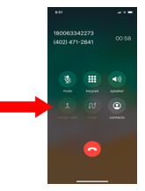
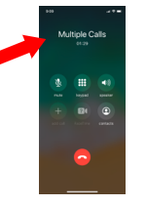
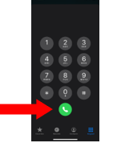
Screenshots – iPhone

Screenshots – Android
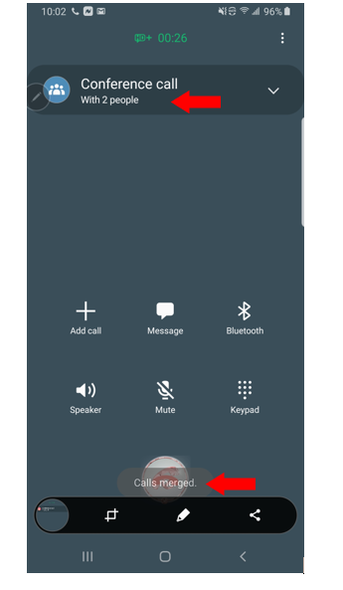
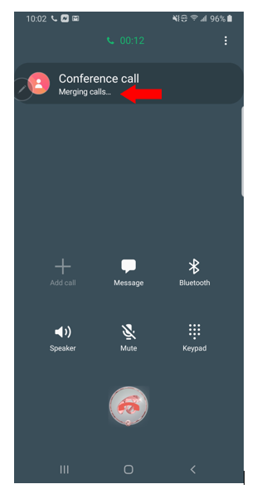
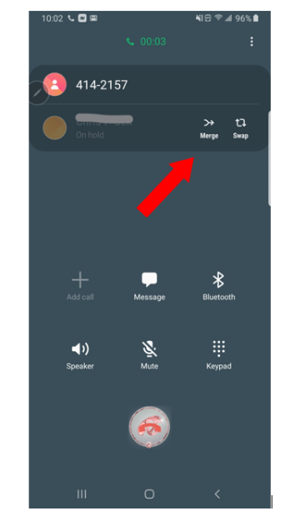
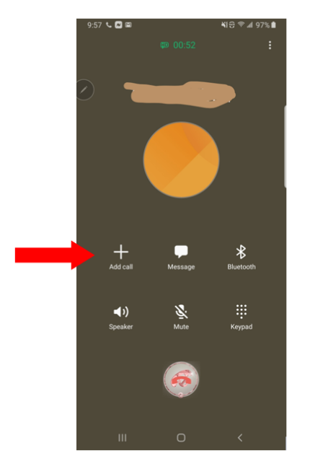

Scanning Documents

iPhone
- Locate the Notes app from you the home page of your iPhone. Your notes Notes app may be found under folders entitled Productivity or Utilities.
- Open the app.
- Create a new note:
  - On the bottom right hand corner of your screen, you will see a picture of a square with a pencil.
  - Click on this icon.
- At the bottom of your screen, you should see an icon with a picture of a camera. Click on this icon to get access to the scanning feature.
- Click Scan Documents.
- Scanning the document:
  - Hold your phone over the document you wish to scan.
  - Ensure the entire document is in view.
  - Press the circle when you are ready to scan.
  - The app will provide you with the option to crop the area of the photo you would like to scan.
    - You can move the lines to enlarge or reduce the section you want scanned.
    - Touch the circle on the edges of the line to move the line over the area you want scanned.
Example
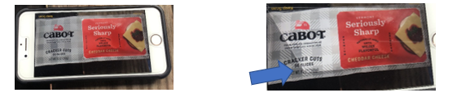
Initially, the phone is only prepared to scan the red section of the Cabot cheese container. By moving the line to the location needed, you can scan the full package.
The line shown here is not quite where it needs to be to scan the whole document.
- Saving and scanning a second page:
  - Click Keep Scan. The app will provide a message that it is ready for the next scan. If you are done, click Save.
  - If you want to scan a second page, position the second page of the document under the phone.
  - Repeat the process above to scan the second page.
- Saving the scanned document:
  - Click Save when you are done scanning all the pages you need.
- Sending the document:
  - You can send this scanned document via email or text.
  - Click the icon of an arrow pointing upward, which should be located in the upper right-hand corner of the screen.
  - Click “Mail” to email the scanned document.
  - Enter the recipient's email address and create a subject line that describes the document.
  - When ready, click the arrow located in the top right-hand corner of the phone. The scanned copy of the document will be automatically inserted.
  - Consider using a secure email when sending documents to a beneficiary.
- Where is the scanned document?
  - Your scanned document is now located in the Notes app on your phone.
  - Name this note for easier reference. Click on the note and use your keyboard to name the document. It will now appear in the My Notes section.

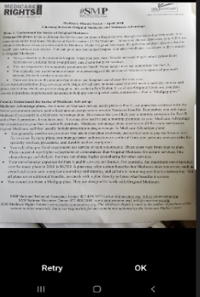
Android
- Locate your Google Drive app.
- Open the Google Drive app.
- In the bottom right-hand corner of the screen, tap Add.
- Tap Scan.
- Take a photo of the document you'd like to scan. Click OK.
- For multiple pages:
  - After every page you scan, tap the icon with a plus sign in the bottom left-hand corner of your screen.
- To adjust the scan area:
  - Tap Crop
- To save the finished document, tap Save.
  - You will be able to save the document to the appropriate Drive.
  - Tap Save, and then Done.

Tablet
- Locate your Google Drive app.
- Open the Google Drive app.
- On the bottom right-hand corner of your screen, tap the blue plus sign icon.
- To select the scan function, tap the picture of a camera labeled “Scan.”
- Position the document below the tablet. When you are ready to scan, click the blue button.
- Use the arrows to adjust the cropped area and click the check mark icon when you are done.
- Your scan is now located in your Google Drive.
- Click onto the three vertical dots in the top right-hand corner to view your Options menu. Click on Send a Copy.
- Select Email to send the scan through email.
- Type in the recipient’s email address and hit Send. Your scanned document will accompany the email.

