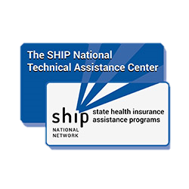­REGISTER NOW!

SPONSORED BY:

WELCOME TO MEDICARE

VIRTUAL FAIR

JUNE 23, 2021 | OPEN FROM 3:00 PM TO 7:00 PM ET

Learn about signing up for Medicare! Go to [www.shiphelp.org](http://www.shiphelp.org) for more details, to see the agenda, and to register.

This fair is for people turning 65 or joining Medicare because of a disability. Learn about Medicare – and all its parts - to assist you in your initial enrollment decisions. There is no cost to attend. Join us online for any length of time!

Get trusted, unbiased Medicare education to help you make Medicare choices that best meet your needs.

There will be national expert presenters on Medicare eligibility, enrollment, and coverage options. Chat with exhibitors from your state health insurance assistance programs (SHIP) for answers to your individual questions.

**State Health Insurance Assistance Programs (SHIPs) are in all 50 states, Washington DC, Puerto Rico, and the U.S. Virgin Islands.** Your SHIP may use another name, locally. Use the SHIP Locator at [www.shiphelp.org](http://www.shiphelp.org) to learn more.



www.shiphelp.org -OR-

www.shiptacenter.org



info@shiphelp.org



877-839-2675